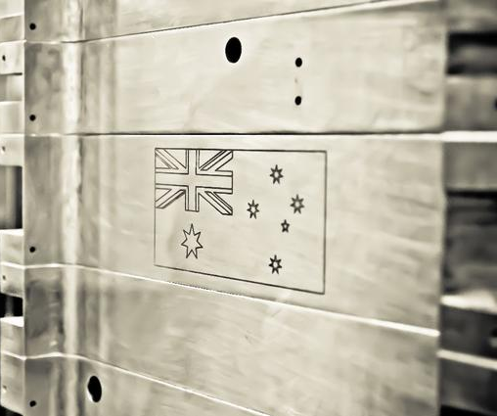 elcome

W

to BLUEsat

Who are we?

BLUEsat is an undergraduate led and run engineering student society building a satellite.

What’s our status?

Thanks to a lot of fantastic work from our members and a grant from the ASRP, we are working hard towards a major milestone next year. In March, 2013, we will be launching satellite students from Alice Springs for three days of intensive testing in the upper stratosphere.

How do we operate?

BLUEsat has five technical teams in active development and an operations team responsible for finance, logistics and sponsorship.

**PCB Team** – routes, tests, and manufactures the PCBs which make up the core electronics of the satellite. Consider this if you are interested in electrical design.

**Power/Solar Team** – designs the system that will power the overall satellite. This team is working on completing the satellite’s battery charge regulator and working on fixing our solar panels to the structure. Consider this if you are interested in photo-voltaics or power.

**Mechanical Team** – is responsible for the physical structure of the satellite which protects internal circuitry from temperature change, shock and vibration. Thermal modeling of the satellite and preparation for the upcoming qualification testing are their main goals. Consider this if you are interested in aeronautics.

**Communications and Telemetry Team** – is responsible for the satellite’s communications with the ground. The satellite can act as an analogue repeater and is able to send and receive digital information over radio. Consider this if you are interested in telecommunications.

**Software Team –** is tasked with the implementation and testing of the robust operating system and software used on BLUEsat’s Critical Systems and Payload computers. The team is working with the FreeRTOS and the L4 based Linux operating systems and developing the drivers and tasks which allow these systems to interact with the satellite hardware.

**The Future –** Last but not least we will be forming a team in the coming months to prepare for the next generation of development after our balloon launch.

Where do you fit in?

BLUEsat is looking for anyone passionate about engineering to volunteer their time and contribute to the project. We don’t assume or require any specific knowledge; we just assume that you are willing to learn. New members are either integrated into active teams or placed in smaller projects under the guidance of one of our senior members.

If you are interested in finding out more send an email to [info@bluesat.unsw.edu.au](mailto:info@bluesat.unsw.edu.au) or come visit one of our weekly development sessions: Saturday 10 am and onwards in EE419.